**LAB 1**

**Install Terraform on Windows**

**STEP 1: Download Terraform File for your Operating System**

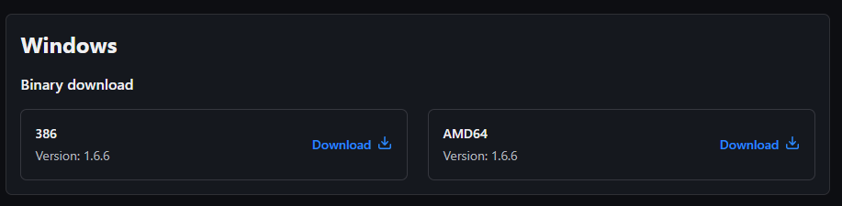

**STEP 2: Extract the file in C: directory**

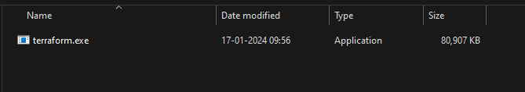

**STEP 3: Edit system environment variables, click on Environment Variables**

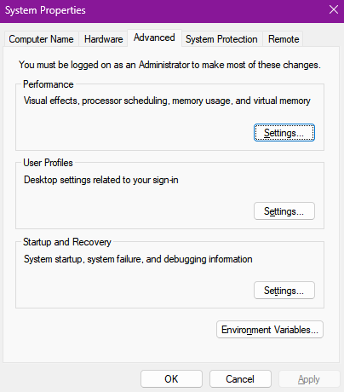

**STEP 4: Click on edit for user and system, select path and edit it.**

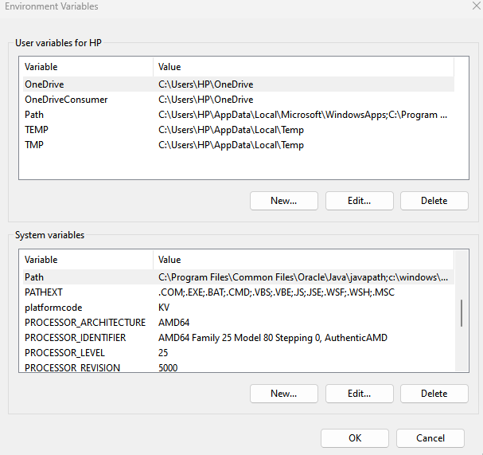

**STEP 5: Paste the directory of the terraform folder you extracted.**

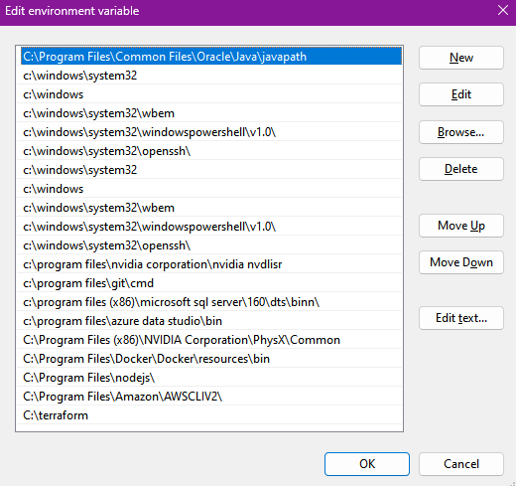

**STEP 6: Click on ‘OK’ on all windows to apply changes to windows.**

**STEP 7: Verify Windows Terraform Installation**

* **Open a new command prompt window.**
* **Enter the command ‘terraform -version’ if installation was successful version will be displayed.**

